**Task5-Gemini**

**Applying Styles Directly to HTML Elements**

**Inline Styles** allow you to apply CSS properties directly to individual HTML elements using the style attribute. This provides a quick and convenient way to style specific elements without creating a separate stylesheet.

**Syntax:**

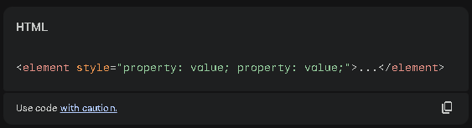

**Example:**

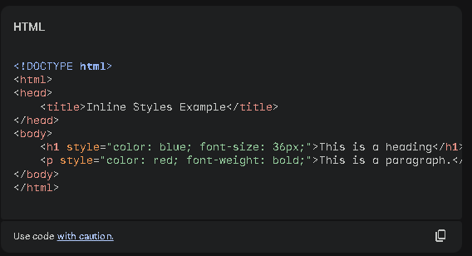

**Resylt:**

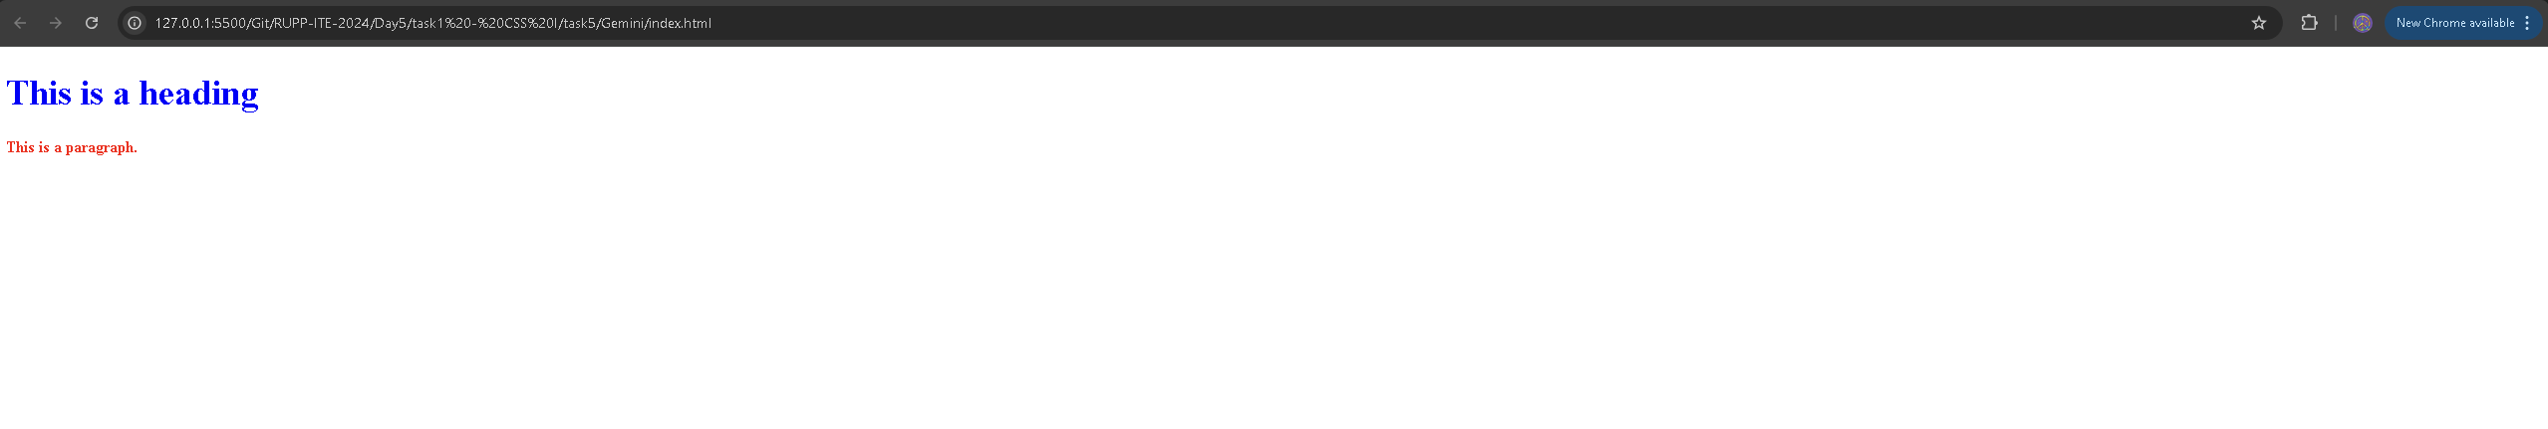

In this example:

* The heading has a blue color and a font size of 36 pixels.
* The paragraph has a red color and is bold.

### Pros of Inline Styles

* **Quick and Easy:** Inline styles are straightforward to apply, making them suitable for small, one-off styling changes.
* **Immediate Effect:** Changes made to inline styles are immediately reflected in the browser without requiring a page reload.

### Cons of Inline Styles

* **Poor Readability:** Inline styles can clutter HTML code, making it harder to read and maintain.
* **Lack of Reusability:** Styles defined inline are specific to the individual element and cannot be reused across multiple elements.
* **Maintenance Issues:** As the number of inline styles increases, managing and updating them becomes more difficult.

**When to Use Inline Styles:**

* **Small, Temporary Changes:** For minor adjustments that don't need to be reused, inline styles can be a convenient option.
* **Prototyping:** While prototyping, inline styles can be used to quickly experiment with different styles before creating a proper stylesheet.

**In general, it's recommended to use external stylesheets for most web development projects to improve code organization, maintainability, and reusability.** Inline styles should be used sparingly for specific cases where they offer a clear advantage.